Resources for Key stage 1,2, and 3 Art Teachers and Parents!
Topic; Landscapes
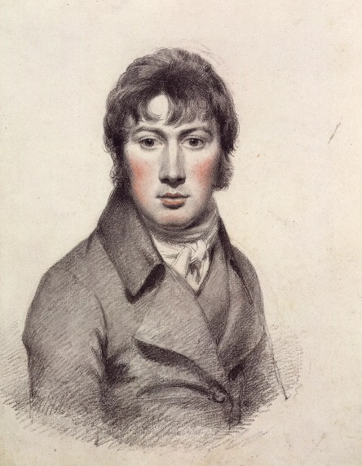
Focus artist: John Constable
The Haywain painting can be found in more detail here for teaching purposes (click below):
https://www.nationalgallery.org.uk/paintings/john-constable-the-hay-wain

Artist: John Constable. Famous for painting the Suffolk countryside in the 17th and 16th Century
Born: June 11, 1776 - Suffolk, England
Died: March 31, 1837 - London, England

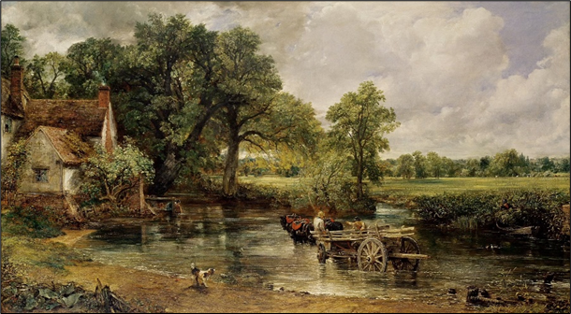

Painting Title: The Haywain
Date painted: 1821

Medium: Oil on Canvas
Specialised subject matter: Landscape
Artistic Movement: ‘Romanticism’ which began circa 1770

Fun facts:

·The River Stour (The water seen in the Haywain) is a subject Constable painted time and time again.

·‘Constable Country’is the name given to his native valley Stour
·Visitors can go and visit the area that Constable is from and view what spots he created his painting from.

The Haywain Activity

Can you draw a modern day Haywain?
Copy the original Haywain and make changes to some of the scenery.
Include a subject you would find in our modern day world. For example, a recycling bin, an electric car. The house could include solar panels on the roof!

Teachers/Parents:
Find images of modern-day items for your pupils to choose so that they are not completing it from their imagination.

Teachers/Parents: Remember if you have downloaded this resource you can upload images of your pupil’s work for me to post and comment on!

